Disaster Management System
By Remotz Systems

Deliverable-1

Project Team

Muhammad Moiz Ansari 23i-0523
Zohaib Umer 23i-0528
Rehan Tajik 23i-0730
Muhammad Tayyab 23i-0738

Semester 6

Supervised by
Ms. Rabail Zahid



Department of Computer Science National University of Computer and Emerging Sciences Islamabad, Pakistan
February 28th, 2026

PART B — Development Methodology (Scrum) — Sprint 1

1. Sprint Backlog for Sprint 1
1.1 Module Name
User Authentication & Disaster Reporting

1.2 User Stories

User Story 1:
Story ID: US-01 | Story Title: Register User
User Story |  | Importance:
As a Citizen, NGO, or Rescue Team member, I want to register an account in the system so that I can access disaster management features according to my role |  | High
 |  | Estimate:
 |  | 3 days
Acceptance Criteria |  | Type:
- The system provides a registration form based on user role (Citizen / NGO / Rescue Team).  - Users must enter required details (Name, CNIC / Registration No / Team ID, Contact Info, Password).  - The system validates entered information.  - If invalid data is entered, it shows an error message and asks the user to enter again.  - Upon successful validation, the system creates the account and confirms registration.  - System logs the registration action for auditing. |  | ☐ Search  ■ Workflow  ☐ Manage Data  ☐ Payment  ☐ Report / View

User Story 2:
Story ID: US-02 | Story Title: Manage Disaster Records
User Story |  | Importance:
As an Admin, I want to manage disaster records so that disaster information remains accurate, updated, and available for coordination and reporting. |  | High
 |  | Estimate:
 |  | 2 days
Acceptance Criteria |  | Type:
- The system displays a list of all disaster records.  - Admin can choose to Add, Edit, or Delete a disaster record.  - The system validates all changes before saving.  - If a database error occurs, the system shows a failure message.  - The system maintains logs of all updates for auditing. |  | ☐ Search  ☐ Workflow  ■ Manage Data  ☐ Payment  ☐ Report / View

User Story 3:
Story ID: US-03 | Story Title: Add Disaster Record
User Story |  | Importance:
As an Admin, I want to add a new disaster record so that new disaster incidents are properly recorded and tracked in the system. |  | High
 |  | Estimate:
 |  | 1 day
Acceptance Criteria |  | Type:
- The system provides a form to enter disaster details (type, location, severity, date, description).  - The system validates required fields.  - If invalid or incomplete data is entered, the system shows an error message.  - Upon confirmation, the system stores the disaster record in the database.  - The system logs the addition of the disaster record. |  | ☐ Search  ☐ Workflow  ■ Manage Data  ☐ Payment  ☐ Report / View

User Story 4:
Story ID: US-04 | Story Title: Edit Disaster Record
User Story |  | Importance:
As an Admin, I want to edit an existing disaster record so that I can update severity, status, or assigned teams when new information becomes available. |  | Medium
 |  | Estimate:
 |  | 2 days
Acceptance Criteria |  | Type:
- The system allows the admin to select an existing disaster record.  - The system displays editable disaster details.  - The system validates updated information.  - If invalid data is entered, the system shows an error message.  - Upon confirmation, the system updates the disaster record in the database.  - The system logs the modification with a timestamp. |  | ☐ Search  ☐ Workflow  ■ Manage Data  ☐ Payment  ☐ Report / View

User Story 5:
Story ID: US-05 | Story Title: Delete Disaster Record
User Story |  | Importance:
As an Admin, I want to delete a disaster record so that incorrect or duplicate disaster entries can be removed from the system. |  | Medium
 |  | Estimate:
 |  | 2 days
Acceptance Criteria |  | Type:
- The system allows the admin to select a disaster record for deletion.  - The system asks for confirmation before deleting.  - If confirmed, the system removes the record from the database.  - If deletion fails due to database error, the system shows a failure message.  - System logs the deletion action for auditing purposes. |  | ☐ Search  ☐ Workflow  ■ Manage Data  ☐ Payment  ☐ Report / View

User Story 6:
Story ID: US-06 | Story Title: Report Disaster
User Story |  | Importance:
As an emergency responder or Citizen, I want to submit a disaster report so that the admin is immediately aware of the incident and a rescue operation is started. |  | High
 |  | Estimate:
 |  | 4 days
Acceptance Criteria |  | Type:
- System provides a form to select disaster type  - Users can validate the entered information  - If invalid data is entered it shows an error message and asks the user to enter again  - Upon user confirmation the system records the disaster and notify authorities |  | ☐ Search  ■ Workflow  ☐ Manage Data  ☐ Payment  ☐ Report / View

User Story 7:
Story ID: US-07 | Story Title: Send Notifications / Alert
User Story |  | Importance:
As an admin I want to send notification/alert by providing necessary information such as location and severity so that the stakeholders are notified about the disaster. |  | High
 |  | Estimate:
 |  | 4 days
Acceptance Criteria |  | Type:
- System prompts the admin to specify type of disaster  - If necessary information is missing the system asks the admin to complete them  - The system forwards the details to the relevant stakeholders |  | ☐ Search  ■ Workflow  ☐ Manage Data  ☐ Payment  ☐ Report / View

User Story 8:
Story ID: US-08 | Story Title: Broadcast Alert to Stakeholders
User Story |  | Importance:
As a system I want to broadcast alerts to stakeholders so that the citizens and NGO’s and the rescue teams receive notification to prepare and respond effectively. |  | High
 |  | Estimate:
 |  | 2 days
Acceptance Criteria |  | Type:
- System connects to external communication channels to forward notifications.  - Stakeholders must receive emergency alerts in 15 seconds  - If alerts do not reach the system should resend it.  - Critical alerts should be delivered even if system is in heavy load |  | ☐ Search  ■ Workflow  ☐ Manage Data  ☐ Payment  ☐ Report / View

User Story 9:
Story ID: US-09 | Story Title: Send Notifications
User Story |  | Importance:
As an admin, I want to send assignment notifications to NGO and rescue teams so that they know their task and begin their operations. |  | Medium
 |  | Estimate:
 |  | 2 days
Acceptance Criteria |  | Type:
- System notifies the selected NGO or rescue team about the disaster assignment  - The system allows the NGO or rescue team to acknowledge the assignment  - Upon acknowledgement, the system must update disaster record and team status |  | ☐ Search  ■ Workflow  ☐ Manage Data  ☐ Payment  ☐ Report / View

User Story 10:
Story ID: US-10 | Story Title: View Disaster Alerts
User Story |  | Importance:
As a citizen, I want to view current disaster alerts so that I am aware of the current disaster events for my safety |  | High
 |  | Estimate:
 |  | 1 day
Acceptance Criteria |  | Type:
- System retrieves and displays the list of current disaster alerts  - The citizen can see the details of the disaster by clicking on it.  - If no alert exits the system displays “No current disaster alerts” |  | ☐ Search  ☐ Workflow  ☐ Manage Data  ☐ Payment  ■ Report / View

1.3 Structured Specifications
Specification 1 - US-: Manage Disaster Records
Use Case Section | Comment
Use Case Name | Manage Disaster Records
Scope | Disaster Management System
Level | User-Goal
Primary Actor | Admin
Stakeholders and Interests | Admin: Wants to create, update, delete and maintain accurate disaster records.  Users/NGOs/Rescue Teams: Depend on accurate data for effective planning and response in the future.
Main Success Scenario | Actor Action System Response  1. Admin selects the option to manage disaster records.  2. The system displays a list of disaster records.  3. Admin adds new records/modifies existing records.  4. System saves/validates records.  5. Prompts admin upon status of completion.
Extensions | - If a disaster record does not exist, the system notifies the admin  - If data is in the wrong format, the system prompts the admin for correct data.  - If database error occurs, the system notifies the admin.
Pre-conditions | - Admin is authorized  - Database is connected
Post-conditions | - Disaster records are successfully recorded.  - Logs maintained for future reporting.

Specification 2 - US-10: View Disaster Alerts
Use Case Section | Comment
Use Case Name | View Disaster Alerts
Scope | Disaster Management System
Level | User-Goal
Primary Actor | Citizen , Admin
Stakeholders and Interests | Citizen: Wants to stay informed about current disaster events for safety.  Admin: Needs visibility of all reported disasters for effective coordination.  Rescue Team/NGO: May use alerts to prepare for response.
Main Success Scenario | Actor Action System Response  1. The actor selects the option to view disaster alerts.  2. System retrieves and displays the list of current disaster alerts  3. The actor selects a specific disaster alert.  4. The system shows details: location, severity, status, and response teams assigned.
Extensions | - If no alerts exist, the system displays: “No current disaster alerts.”  - If network/data error occurs, system prompts user to retry
Pre-conditions | - Disasters must be reported in the system.  - Citizen must have access to system application.
Post-conditions | - Citizen/Admin successfully views the disaster alerts.

Specification 3 - US-07: Send Notification/Alert
Use Case Section | Comment
Use Case Name | Send Notification/Alert
Scope | Disaster Management System
Level | User-Goal
Primary Actor | Admin
Stakeholders and Interests | Admin: Wants to efficiently and quickly notify stakeholders about a disaster.  NGO/Rescue Team: Needs timely alerts to prepare and respond effectively.  Citizens: Expect to receive disaster alerts to take safety precautions as early as possible.
Main Success Scenario | Actor Action System Response  1. Admin decides to send a notification/alert.  2. The system prompts the admin to specify the type of disaster alert.  3. Admin provides necessary information such as location of disaster, its severity and instructions.  4. The system accepts/validates information.  5. System forwards alert to all registered stakeholders.  6. Stakeholders receive the notification in real-time.
Extensions | - If necessary information is missing, the system prompts the admin to complete them.  - If alerts don’t reach some users, the system resends the alert.
Pre-conditions | - Admin is authorized.  - System is connected to communication channels (
Post-conditions | Notifications are forwarded to all relevant stakeholders.

Use Case Section | Comment
Use Case Name | Report Disaster
Scope | Disaster Management System
Level | User-Goal
Primary Actor | Citizen
Stakeholders and Interests | - Citizen: Wants to let admin know to receive rescue help and resources timely.  - Admin: Wants to get informed about disaster to start taking actions.
Main Success Scenario | Actor Action System Response  1. The user selects the option Report Disaster.  2. The system shows the form input.  3. The user enters the required details.  4. The system validates the entered information.  5. User confirms to report the disaster.  6. The system notifies the admin.  7. System updates the reporting log.
Extensions | 4. Invalid data entered - Shows an error message “Invalid data entered”, and prompts the user to enter data again.  6. Notification failure - The data is stored on the system temporarily until the admin is notified about it.  7. Log failure - System shows “Update failed. Try again later.”
Pre-conditions | - The user has access to the system application.  - The system is online and connected to disaster database.
Post-conditions | - Disaster report is recorded in the database.  - Authorities are notified of the new disaster report.  - Rescue operations may be initiated based on the report on admin’s command.
Specification 4 - US-06: Report Disaster

2. Scrum Board (Trello Snapshots)
2.1 Snapshot 1 — Initial Backlog Upload
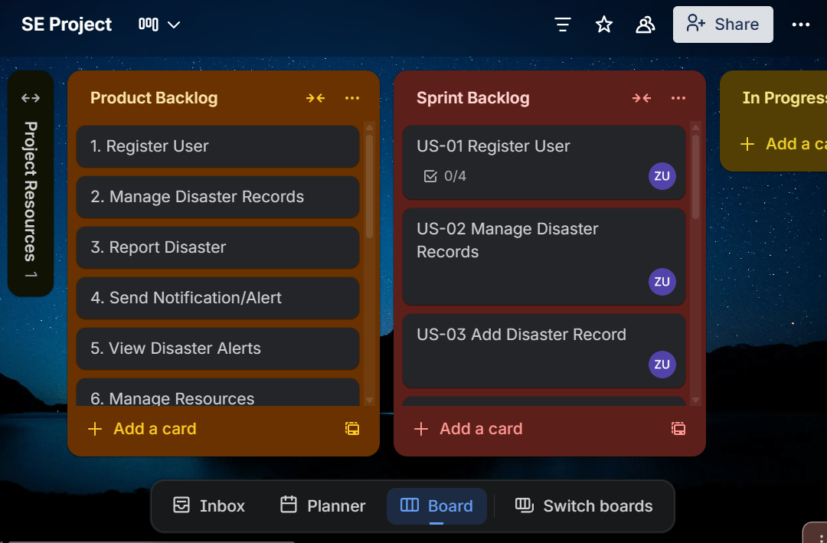

2.2 Snapshot 2 — Mid-Sprint Progress
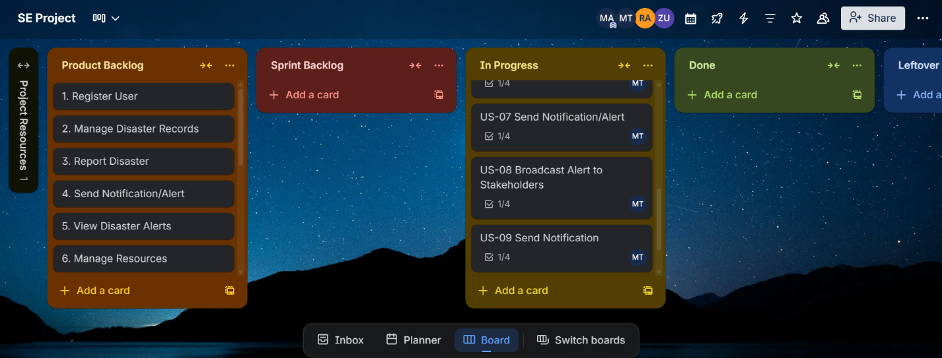

2.3 Snapshot 3 — End of Sprint
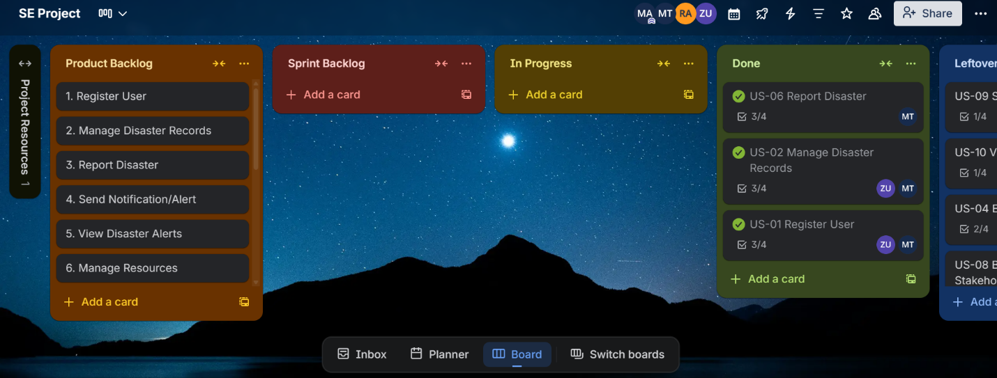

2.4 Product Burn-Down Chart — Sprint 1

